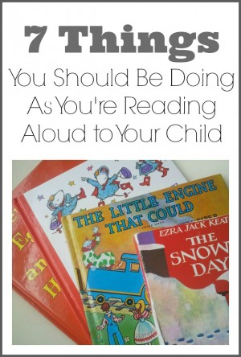

Reading daily with your child is critical to their development in many ways. There is no better way to increase vocabulary, teach literacy fundamentals, and expose your child to images and words to which they would otherwise not be exposed.
However, just saying the words on the page, while giving some benefits to your child, will not make the experience as productive as possible. By adding just a few small changes to your read-aloud time, you will be greatly increasing your child’s reading preparedness. Here are seven suggestions to make read-alouds the best learning experience possible every time you read together:
Read the Title, Author’s Name, and Illustrator’s Name-It’s important for children to become familiar with what these three things mean. Explain what author and illustrator mean. It’s also great for them to understand that every book is written and illustrated by real people.
Ask Your Child to Make Predictions-Read the title and look at the cover, then ask your child to tell you what they think might happen in the book. Most children will be quite uncomfortable with this in the beginning since they don’t know the answer, and they want to please you by saying only correct answers. Encourage them by saying that there is no wrong answer, but rather you just want them to take a guess. Ask them again in the middle of the book to make a prediction about how the story will end, and you could even make your own prediction and sometimes model that it’s okay to make an incorrect prediction.
Ask Your Child What Is Happening In the Pictures-It may not seem like pictures are as significant of a learning tool as the words, but when your child examines what is happening in a picture and explains it, it develops their inference skills. Just make sure not to do it with EVERY picture. Once or twice during a book will give them a chance to practice without completely interrupting the flow of the book.
Move Your Finger as You Read-By moving your finger underneath the words as you read, your child understands that you read left to right and top to bottom. It also helps children from a very young age to understand that the words you are saying are those written on the page, not just your own thoughts. However, this one takes a fine balance. Please don’t move your finger under every word on every page in every book. As a matter of fact, you should probably read most books without doing this at all. But every couple of days, use this trick on a page or two just so that your child will begin to take notice of some very important literacy fundamentals.
Ask Questions-Again, this involves a balancing act. Please don’t ask your child three questions per page. As a matter of fact, don’t even ask them one question per page. I think that asking a question every few pages is frequent enough to check your child’s understanding without breaking the flow of the story. You can ask basic recall questions, like “What did Mom say she needed at the store?” as well as reasoning questions like “How do you think Mom will get to the store?” and you can also throw in expansion questions like “What would you buy at the store to cook for dinner?”. The goal is to engage your child in the story, but beware that if you stop too often you will turn your child off to reading with you altogether because it will become a frustrating situation to them.
Reread the same books again…and again…(and again)-Most adults like to read a book once, and unless it’s a favorite, they will move on to another one. However, children like to read the same books over and over again. This helps them to make permanent in their mind the words and concepts that their brain is understanding. Regardless of the repetition, it is helping your child learn when you happily read and re-read books.
Really enjoy the book with your child-It really doesn’t matter if you follow each of these rules, AND establish a 1,000 book collection for your child, AND take them to the library twice a week. If you don’t take time to truly enjoy a book with your child, the likelihood of them enjoying it greatly decreases. Some of my children’s favorite books have been my favorite books, and I think it’s because my enthusiasm for the book shows. Enjoy the book and enjoy the time, because both are over much too soon.

Happy Reading!

